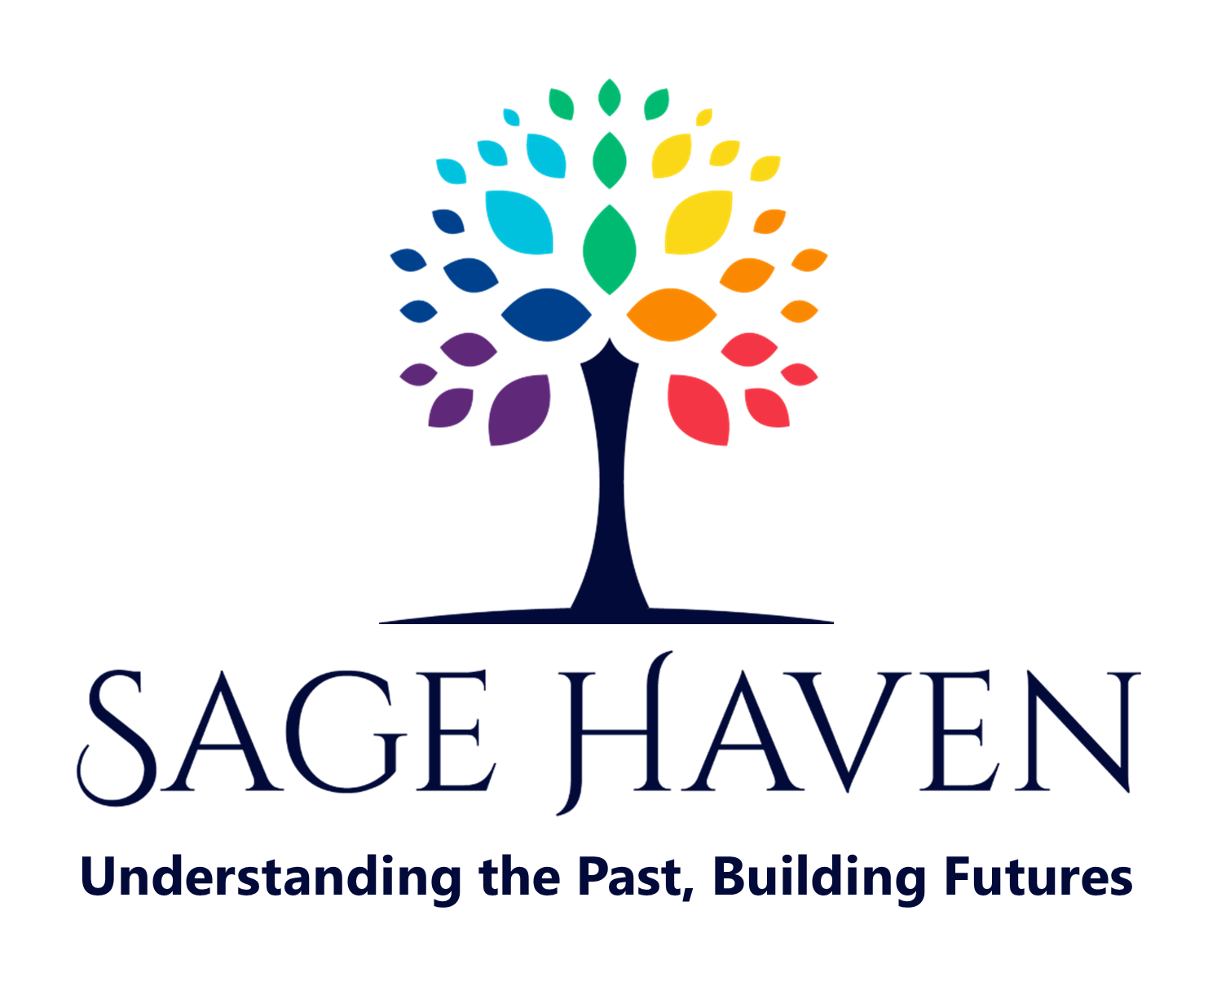
SHAPING A BRIGHTER FUTURE
Leave a Lasting Legacy for Women, Children and Community Members Surviving Violence
_______________________________________________________________________________________________________

Gifts of Life Insurance Policies

Turn a Modest Premium into a Lasting Impact

Overview
Life insurance is a simple way to make a significant gift. By naming Sage Haven Society as the owner or irrevocable beneficiary of your policy, you can create a lasting legacy for the community.

Benefits
- Modest premium payments result in a large future gift.
- Receive tax benefits for the policy's cash value or premiums.
- Ensure your legacy supports the causes you care about.

How It Works
1. Transfer ownership of an existing policy to Sage Haven Society or name them as the irrevocable beneficiary.
2. Sage Haven receives the policy's value when it matures.
3. You receive tax benefits for your contributions.

Our Information
Legal Name: Sage Haven Society
Charitable Number: 10785 2584 RR0001
Society number: S-15795
Effective date of status: 1980-08-11

Contact Us
Contact: Ellen Frood, Executive Director
Address: 3082 3rd Avenue, Port Alberni, BC V9Y 2A5
Phone: 250-736-0702
Email: executivedirector@sagehavensociety.org
Website: sagehavensociety.org

Please contact your lawyer or for legal advice. Talk to your family about your plans.

